The Copenhagen Resolution
The Copenhagen Resolution ⁶⁵ was passed at the conference “The Shadow Side of Wireless Society” in Copenhagen, Denmark on October 9th, 2010. It is based on previous international appeals, resolutions and the Bioinitiative Report from Medical Doctors and Scientists who state the need for prevention of damage to public health from the exposure to radiation from Wireless Technology. It makes the following demands:

* A considerable lowering of guidelines and exposure to wireless microwave radiation, to a biologically based precautionary level, with a peak-level maximum of 0.6 V/m as recommended by the BioInitiative report.
* Information and official warnings for the general public, regarding the health risks from wireless microwave radiation – with emphasis on increased risks for pregnant women and children.
* Warning labels on wireless radiation emitting products and a determination by the producers to design such products to emit as little radiation as possible, and emit radiation only when necessary.
* Restrict and discourage children`s access to, and use of wireless radiation emitting products.
* Electro Hyper Sensitivity must be officially recognized as a functional impairment.
* Enable and respect local community influence on the location of wireless base stations and a full disclosure of all existing and planned wireless base-station locations.
* Minimize wireless radiation exposure in public spaces occupied by vulnerable groups, like schools, day care facilities and public transport.
* Establish White-Zones: low-radiation communities where Electro Hyper Sensitive people can live as well as providing financial support for shielding from wireless radiation in existing homes.
* Promote health safe alternatives to wireless technology.
* Independent research must be undertaken.

For references see http://www.scribd.com/doc/58140784/References-for-Unwittingly

Recommended Books: The Zapping of America, The Body Electric,
Cross Currents, Electromagnetic Fields, Would You Put Your Head in a Microwave Oven, Dirty Electricity, Zapped, Disconnect, Radiation Rescue
Recommended Movies/Videos: Full Signal, Public Exposure, Radiant Day, Panorama: WiFi, A Warning Signal, Dear Helen Clark, The Cell Phone Song

The Sunflower Project
In the past few years, there has been a dramatic increase in environmental illnesses like Multiple Chemical Sensitivity (MCS), Atopic Dermatitis, Asthma, Autism, CFIDS, ADHD, and so on due to an increase in environmental pollutants (visible and invisible). The primary goal of the Sunflower Project⁶³ (the brainchild of Kato Yasuko of Sapporo, Hokkaido, Japan) is to create a clean, safe, and healthy living environment for all life and living beings on this planet.

Brought to you by the
International Coalition for an EMR-Safe Planet (IC-ESP)

The Sunflower Project EMR Fact Sheet 
Are You “Unwittingly” Being Affected By Electromagnetic Radiation?

While we may not be able to sense it with your five senses (sight, sound, smell, taste, touch), we are now being exposed to from thousands to millions of times¹ the amount of electromagnetic radiation we would normally get from natural sources (Sun, Earth, Stars etc.).

Worldwide, a rapidly increasing number of people are becoming sensitive to the electromagnetic radiation (EMR) emitted by cell phone towers, cell phones, WiFi, WiMax, TETRA², etc. In fact, several European scientists have predicted that by 2017, 50% of the population may be electro-sensitive (ES) ³.

If you experience any of the following “unexplained” symptoms, you may in fact be unknowingly exhibiting the symptoms of ES yourself:

•Headaches •Nausea •Brain Fog •Memory Problems • Fatigue
•Dizziness •Insomnia •Heart Pain/Palpitations •Swollen Lymph Nodes •Intestinal Disturbances •Eye Pain •Dry Eyes •Vision Problems
•Night Sweats •Excessive Thirst •Increased Allergies/Sensitivities

If you put a frog in hot boiling water, it will jump out. However, if you put a frog in cold water and slowly heat the water, you can cook the frog because it will not notice the gradual change in temperature. Well, with the ever-increasing amount of ambient electromagnetic radiation in our environments, we might be experiencing the same fate as the frog that does not realize it is being cooked.

As a human being aware of being affected by electromagnetic radiation, I would like ask you to consider the possibility this technology might adversely be affecting you and others around you and to be more conscious, considerate and compassionate when using your devices around other human beings– especially in buses, trains, airplanes, where this radiation is reflected and increased. Thank you!
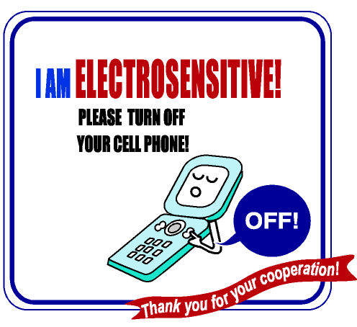
The Research: Biological Effects
Thousands of Studies Are Showing Biological Effects
Increases Cancer Risk
* 200% increase in Brain Tumors and Acoustic Neuromas for those using a cell phone on the same side of the head for 10 years (average 30 minutes per day) ⁴⁸.
* Children who start using a cell phone before the age of 20 are 5 times more likely to get brain cancer ⁴⁹.
* Cell Phone Radiation Breaks DNA leading to mutated genes cancers, and deformities ⁵⁰.
* There is evidence that we are indeed moving towards a brain tumor epidemic. Experts are predicting a 2000% increase in brain tumors the next 20 years ⁵¹.
Affects Fertility and Breaks DNA
* Cell Phone Use/Exposure decreases sperm count and sperm motility (the ability for the sperm to find its way to the egg) ⁵².
* Experiments show increased rates of deformities/mortality in chick embryos ⁵³.
Triggers (and may cause) Allergic Reactions
*Increases allergic reactions like eczema, asthma, and hay fever ⁵⁴.
Disrupts Hormones and Neurotransmitters
* EMR exposure changes the levels of hormones and neurotransmitters in the brain like melatonin, serotonin, dopamine, norepinephrine, and acetylcholine⁵⁵. Changes in these hormones/neurotransmitters are associated with sleep disturbances, Sudden Infant Death Syndrome, Attention Deficit Hyperactivity Disorder (ADHD), CFS, miscarriages, heart disease, cancer, Alzheimer`s, Parkinson`s, depression, behavior changes, chemical sensitivities, and suicide⁵⁶.
* Produces an (initial) increase in the adrenal stress hormones – Adrenaline and Cortisol – connected with restlessness and anxiety and eventuating in adrenal exhaustion⁵⁷.
Weakens Immune System
* Research has shown that just having a wireless device on your body in standby mode can weaken your immune system⁵⁸.
* Decreases Natural Killer Cell counts necessary for defending against pathogens and destroying abnormal (virally-infected and cancer) cells⁵⁹.
* Changes the T-helper/T-suppressor (T4/T8) cell ratio – from normal to abnormal – which has been shown to lead to increased susceptibility to viral, fungal, and bacterial infections⁶⁰. Symptoms include "sore throats, low-grade fevers, weakness, persistent fatigue, and swollen lymph glands⁶¹."
Can Damage Kidney and Heart Function
In a study carried out by Dr George Sajin at the European Research Institute for Electronic Components based in Bucharest, samples of blood were exposed to varying degrees of microwave radiation over a period of between 10 and 60 hours. Even at levels lower than those emitted by mobile phones, the cells leaked hemoglobin. The unsequestered iron from hemoglobin can accumulate in – and hence damage – kidney and heart tissue ⁶².
Affects Behavior of Children of Pregnant Mothers Who Used Cell Phones
* A large study, surveying more than 13,000 children, found that women who used mobile phones when pregnant were more likely to give birth to children with behavioral problems. These included developing hyperactivity and difficulties with conduct, emotions and relationships by the time they reached school age. The likelihood was even greater if the children themselves used the phones before the age of seven ⁶³.
WHO-Acknowledged Studies Find Cancer Clusters Around Cell Towers
* 80% of (W.H.O. acknowledged) studies on people living in the vicinity of mobile-phone base-stations, show a significantly increased risk of neurological diseases, impaired well-being and cancer ⁶⁴.

What is Electro-sensitivity/Microwave Sickness?
Electro-sensitivity/Microwave Sickness is a condition where a person feels sick when exposed to the EMR given off by cell phone towers (masts), DECT⁴, WiFi; and electronic devices such as mobile phones, and computers. Symptoms appear when the person is exposed to the offending EMR and diminish as the person moves out of range of the EMR.

Major Symptoms: (Very often appearing with the installation of a nearby cell-phone tower, a home WiFi [Wireless Internet] or DECT system. [Cancer clusters start forming around cell towers after between three & seven years⁵.])
•Headache •Sleep disturbances (Insomnia) •Dizziness •Nausea •Heart Palpitations •Heart Pain •Concentration Problems •Fatigue •Listlessness •Indigestion •Reddening of Skin •Tingling Sensations •Anxiety Attacks •Memory Problems •Swollen Lymph Nodes •Excessive Thirst •Frequent Urination •Vision Problems • Tinnitus (Ringing in the Ears), etc.


Fifty Percent of Population Affected by Year 2017?
There has been a drastic increase in the number of people affected by EMR and it is predicted that by the year 2017 over half the population may suffer from symptoms of electro-sensitivity. In 2008, 57.25 million prescriptions for sleeping pills were issued in the US.⁶; brain tumors are the leading cause of cancer death in children⁷; an estimated one in 110 children (in the USA) now suffer from Autism Spectrum Disorders (ASD)⁸ – up from 1 in 2000 in the 70s⁹; one in four Americans now suffer from diabetes or pre-diabetes conditions¹⁰ and one in seven couples suffer from fertility problems¹¹.

Deformed cows near cell phone towers in Germany are just one example among many animal deformities appearing around the world. (Research has also connected the worldwide disappearance of frogs, birds, and insects [most recently bees] with the dramatic increase of electrosmog permeating our planet.¹²).
You Have Been Warned: The Momentum Is Building!
In 1971, researchers from the USSR Institute of Labor Hygiene and Occupational Diseases described a comprehensive set of symptoms, identified as Microwave Sickness. The initial symptoms were low blood pressure and slow pulse. The second stage includes headaches, dizziness, eye pain, sleeplessness, irritability, anxiety, stomach pain, nervous tension, inability to concentrate, hair loss, which are eventually followed by adrenal exhaustion and ischemic heart disease¹³. In 1972, Zory R. Glaser of the Naval Medical Research Institute wrote a paper entitled “Bibliography of reported biological phenomena (‘effects’) and clinical manifestations attributed to microwave and radio-frequency radiation” reviewing over 2000 studies, which found a multitude of problems including “headaches, insomnia, restlessness, fatigue, seizures, convulsions, heart problems, dizziness, memory loss,” and so on¹⁴. By 1977, Paul Brodeur`s book The Zapping of America¹⁵ further warned of the dangers of electropollution. In 1985, Dr. Robert Becker warned again in his book The Body Electric¹³ of the dangers of electropollution. Further warnings were issued in B. Blake Levitt`s book Electromagnetic Fields¹⁶ in 1995. In 1998, it was agreed at the Vienna Resolution¹⁷ that the biological effects of low-intensity EMFs were scientifically established. In 2002, German medical doctors - the Interdisciplinary Society of Environmental Medicine - issued concern about wireless technology (cell phones, DECT, etc.) in the Freiburger Appeal¹⁸ (reaching close to 40,000 signatories) after finding a cause-and-effect relationship between “a dramatic rise in severe and chronic diseases” (e.g. behavioral disorders, ADD, blood pressure disorders, heart attacks and strokes, brain-degenerative diseases, & cancers like leukemia and brain tumors) with increased exposure to EMR. In 2005, the World Health Organization (WHO) officially recognized electro-sensitivity as a “real and sometimes disabling condition” ¹⁹. Also in 2005 the Vienna Doctors Chamber (Wiener Arztekammer) – after the REFLEX²⁰ Studies clearly showed genetic damage – created posters (posted in hospital waiting rooms) warning of dangers and listing rules for use²¹. In March 2007, Italy enacted a ban on all cell phones in schools²². In Aug. 2007, a report – issued by an international group of renowned scientists, researchers, doctors, and public health experts – entitled the BioInitiative²³ (www.bioinitiative.org) warns
Wireless technologies that rely on microwave radiation to send emails and voice communication are thousands of times stronger than levels reported to cause some health impacts. Prolonged exposure to radiofrequency and microwave radiation from cell phones, cordless phones, cell towers, WI-FI and other wireless technologies have been linked to physical symptoms including headache, fatigue, sleeplessness, dizziness, changes in brainwave activity, and impairment of concentration and memory.
In Sept. 2007, the German government warned its citizenry not to use mobile phones (only in emergencies) and WiFi²⁴. In Nov. 2007, the London Resolution²⁵ called on governments to protect children from harm posed by EMFs by following the precautionary principle and adopting the Bioinitiative`s recommendation and the city of Paris voted to ban WiFi in its Public Libraries²⁶. In Dec. 2007, an Australian Democrats commissioned discussion paper found microwave radiation from cell phone towers to very likely be behind the drastic rise in disease states like cancer, diabetes, asthma, allergies and Alzheimer’s disease, etc²⁷. In July 2008, Toronto's department of public health issued an advisory warning teenagers and young children to limit their use of cellphones to avoid potential health risks²⁸. During the same month, the director of the University of Pittsburgh Cancer Institute called for caution²⁹ in the use of cell phones while a UK Teacher Union Chief, Philip Parkin called for the suspension of WiFi in all UK schools³⁰. In Sept. 2008, the European Parliament noted that EMF exposure limits were obsolete³¹. In Jan. 2009, the Finnish Radiation and Nuclear Safety Authority (STUK) recommended restricting the use of mobile phones by children³². In March 2009, the Belgium Government voted to reduce its ambient exposure limits to 3V/M³³. In April 2009, members of the European Parliament voted for reductions in EMF exposures³⁴. In May 2009, the French government imposed a ban on cell phones in all primary schools³⁵. In June 2009, the mayors of several French cities requested a trial period for reducing EMF exposures in their cities³⁶ while the country of Liechtenstein voted to adopt the Bioinitiative recommendations of 0.6 V/M³⁷. In May 2010, the controversial Interphone studies finally acknowledged a link between cell phone use and brain tumors³⁸. In June 2010, San Francisco passed a cell phone radiation law, in which stores selling cell phones were required to display the amount of radiation emitted by phone³⁹. The following month, the CTIA (the representative of the wireless industry) sued the city of San Francisco over the law and withdrew its annual conference in San Francisco⁴⁰. In August 2010, a High Court in Italy ruled that an employer who forced his staff to use mobile and cordless was legally responsible for a brain tumor and instructed to pay compensation to the person concerned, plus legal costs⁴¹. In Oct. 2010, Swisscom offered free fiber optics to all Swiss schools⁴². In May 2011, the Parliamentary Assembly of the Council of Europe (PACE) called on governments to take reasonable measures to reduce exposures to electromagnetic fields⁴³, while the WHO`s International Agency for Research on Cancer declared cell phones a possible carcinogen⁴⁴.
The Vienna Doctors Chamber’s Rules for Cell Phone Use
• Cell phone calls should be as few and as brief as possible. Children and teenagers under 16 should not use cell phones.
• Cell phones should not be held near the head while making and receiving calls.
• Cell phones should not be used in vehicles (cars, buses, trains) – the radiation there is higher!
• When sending text messages the cell phone should be held as far away from the body as possible!
• A caller should position herself several meters away from other people – the radiation is harmful to them as well!
• Never use a cell phone to play games!
• Headphones (earplugs) may also be unsafe – the wire may attract radiation!
• Wireless Networks (WiFi, WiMax, etc.) produce high amounts of radiation!
• Always switch your cell phone off at night and never keep it near your head while sleeping.
• Never keep your cell phone in your front pocket – the radiation can affect male fertility.

Before the call. After the call.
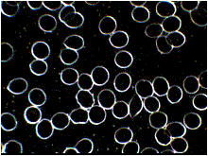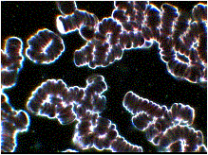
The effect of a ninety-second cell phone call on red blood cells (RBC) on both the user and those within at least 1.7 meters. This affects the RBC’s ability to transport oxygen to and carbon dioxide away from cells⁴⁵.

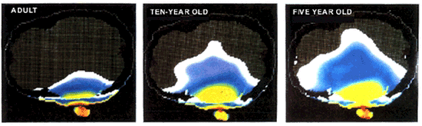
The amount of radiation penetration of the skull of an adult, a 10-year old, and a 5-year old⁴⁶.
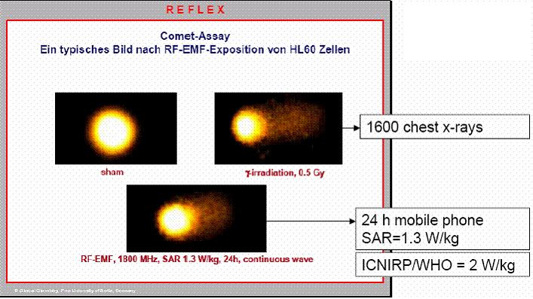
The REFLEX studies clearly shows DNA breaks. The photo in the top left corner is a normal cell. The photo on the right is a cell exposed to 1600 chest x-rays. The photo on the bottom is a cell exposed to 24 hours of cell phone radiation. The trails coming out of the cell are called micronuclei –broken DNA leaking out of the cells⁴⁷.

